Problem Set 8 – Multiple Regression Part V

Problem 1 (20 points)
Please access the Life Expectancy dataset. These data are from Kaggle. The Global Health Observatory (GHO) data repository under World Health Organization (WHO) keeps track of the health status as well as many other related factors for all countries. Those data are made available to the public for the purpose of health data analysis. These data are from 193 countries and were collected from the same WHO data repository website. The data was collected from WHO and the United Nations website with the help of Deeksha Russell and Duan Wang. The dataset consists of:
Response:
- life expectancy

Regressors:

- adult Mortality
- infant deaths
- alcohol
- percentage expenditure
- hepatitis B
- measles
- BMI
- under-five deaths
- polio
- total expenditure
- diphtheria
- HIV/AIDS
- GDP
- Population

Please answer each of the following questions. So that your answers remain focused, you are to include ONLY the item(s) requested (else, your earned credit will be reduced).
- (5 points) Regress “life expectancy” on the fourteen regressors listed here. Copy and paste the Summary of Fit table and Parameter Estimates table showing the VIFs in the space below

Term | Estimate | Std Error | t Ratio | Prob>|t| | VIF
Intercept | 63.884851 | 0.643718 | 99.24 | <.0001* | .
Adult Mortality | -0.023028 | 0.001105 | -20.84 | <.0001* | 1.6875215
infant deaths | 0.1230713 | 0.012679 | 9.71 | <.0001* | 206.61394
Alcohol | 0.3428187 | 0.03198 | 10.72 | <.0001* | 1.4611879
percentage expenditure | -0.000116 | 0.000216 | -0.54 | 0.5925 | 12.716373
Hepatitis B | -0.007429 | 0.005341 | -1.39 | 0.1645 | 1.6459446
Measles | -1.023e-5 | 1.287e-5 | -0.80 | 0.4267 | 1.4823833
BMI | 0.0917944 | 0.006315 | 14.54 | <.0001* | 1.3693283
under-five deaths | -0.09456 | 0.009199 | -10.28 | <.0001* | 197.63171
Polio | 0.0186246 | 0.006176 | 3.02 | 0.0026* | 1.6917623
Total expenditure | 0.1441016 | 0.04874 | 2.96 | 0.0032* | 1.1053671
Diphtheria | 0.0330198 | 0.007087 | 4.66 | <.0001* | 2.0580919
HIV/AIDS | -0.457342 | 0.02143 | -21.34 | <.0001* | 1.470663
GDP | 0.0001418 | 3.367e-5 | 4.21 | <.0001* | 13.141328
Population | 1.9667e-9 | 2.103e-9 | 0.94 | 0.3498 | 1.9319073

- (5 points) Infant Deaths shows up with a very large VIF. Drop that regressor and rerun the model. Copy and paste the Summary of Fit table and Parameter Estimates table showing the new VIFs in the space below.
Term | Estimate | Std Error | t Ratio | Prob>|t| | VIF
Intercept | 63.366883 | 0.659536 | 96.08 | <.0001* | .
Adult Mortality | -0.024605 | 0.001124 | -21.90 | <.0001* | 1.6510539
Alcohol | 0.2922618 | 0.03244 | 9.01 | <.0001* | 1.4224291
percentage expenditure | -0.000154 | 0.000222 | -0.69 | 0.4894 | 12.712224
Hepatitis B | -0.008314 | 0.005491 | -1.51 | 0.1302 | 1.645465
Measles | 2.2528e-5 | 1.277e-5 | 1.76 | 0.0778 | 1.3804153
BMI | 0.0945051 | 0.006486 | 14.57 | <.0001* | 1.36665
under-five deaths | -0.005802 | 0.001036 | -5.60 | <.0001* | 2.3696255
Polio | 0.0221856 | 0.006338 | 3.50 | 0.0005* | 1.6857924
Total expenditure | 0.1335544 | 0.050098 | 2.67 | 0.0078* | 1.1048177
Diphtheria | 0.0410035 | 0.007237 | 5.67 | <.0001* | 2.0303686
HIV/AIDS | -0.459265 | 0.022031 | -20.85 | <.0001* | 1.4705373
GDP | 0.0001483 | 3.461e-5 | 4.28 | <.0001* | 13.136162
Population | 7.1082e-9 | 2.092e-9 | 3.40 | 0.0007* | 1.8093212

RSquare | 0.746231
RSquare Adj | 0.744213
Root Mean Square Error | 4.449032
Mean of Response | 69.3023
Observations (or Sum Wgts) | 1649

- (5 points) Refer to parts a. and b. In three sentences or less, explain generally how the numerical value and statistical significance of each of the parameter estimates changed?
After removing Infant Deaths, most parameter estimates changed slightly, while Under-five Deaths changed substantially from -0.09456 to -0.005802. Most variables maintained their statistical significance, although Population became statistically significant (p = 0.0007), while Measles remained nonsignificant despite changing from a negative to a positive coefficient. Overall, removing Infant Deaths reduced multicollinearity and changed some coefficient estimates without substantially altering the significance of most predictors.
- (5 points) Refer to part c. Keep Infant Deaths out of the model and remove GDP as well (largest VIF at this stage). Rerun. In two sentences or less, compare the fit (as measured by R²) of the full model with that of the model with GDP and Infant Deaths removed.
Removing Infant Deaths and GDP decreased R² from 0.7601 to 0.7417, indicating a slight reduction in model fit. However, the reduced model still explains approximately 74.17% of the variation in life expectancy.

Problem 2 (30 points)
Please access the Brazilian Rent dataset which will be linked on Canvas. This dataset contains 10962 houses to rent with 13 different features:

- City where the property is located.
- Property area.
- Number of rooms.
- Number of bathrooms.
- Number of parking spaces.
- Floor where apartment is located.
- Accept animals?
- Furnished?
- Homeowners’ association tax.
- Rent amount.
- Property tax.
- Fire insurance.
- Total rental cost.

Please answer each of the following questions. So that your answers remain focused, you are to include ONLY the item(s) requested (else, your earned credit will be reduced).
- (2 points) Use JMP to fit a model with variables 2 - 6 as regressors and variable 13 as the response. Generate the hii values for these data and save those to your JMP data table. Order the data table by the hii values, largest to smallest. Copy and paste the Summary of Fit table, the Parameter Estimates table, and a snippet of the ordered data table with the first 10 rows displayed, in the space below.
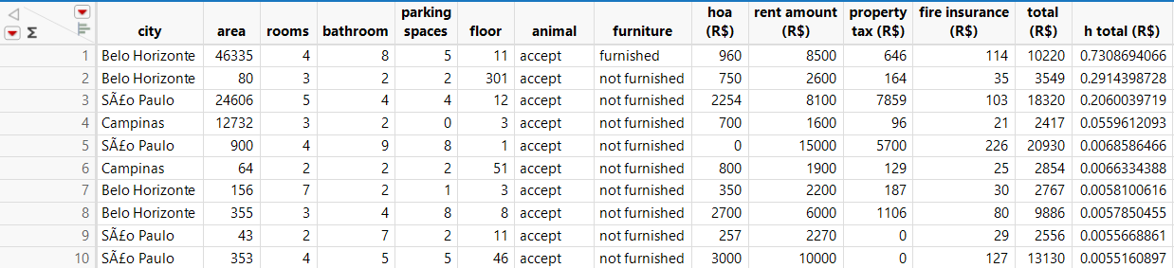

RSquare | 0.041058
RSquare Adj | 0.040475
Root Mean Square Error | 18230.01
Mean of Response | 5458.473
Observations (or Sum Wgts) | 8231

Term | Estimate | Std Error | t Ratio | Prob>|t|
Intercept | 552.08464 | 549.5626 | 1.00 | 0.3151
area | 0.0522346 | 0.339832 | 0.15 | 0.8778
rooms | -1124.775 | 290.7055 | -3.87 | 0.0001*
bathroom | 3559.4516 | 276.9625 | 12.85 | <.0001*
parking spaces | 21.641657 | 249.0334 | 0.09 | 0.9308
floor | 25.913164 | 33.39619 | 0.78 | 0.4378

- (3 points) Focus on the four observations with the largest hii values (one or two orders of magnitude bigger than all the rest). In two sentences or less, indicate which of the six regression variables seem to be different for those four.
Area and Floor appear to be the unusual regression variables among the four observations with the highest leverage. Three observations have exceptionally large areas (12,732–46,335), while another has an unusually high floor value of 301.
- (5 points) Refer to part b. Use the Exclude/Unexclude toggle to set aside those four observations and rerun the model. Copy and paste the Summary of Fit table and the Parameter Estimates table in the space below.

RSquare | 0.046338
RSquare Adj | 0.045758
Root Mean Square Error | 18183.54
Mean of Response | 5456.933
Observations (or Sum Wgts) | 8227

Term | Estimate | Std Error | t Ratio | Prob>|t|
Intercept | 1343.7081 | 578.1678 | 2.32 | 0.0201*
area | 23.269917 | 3.472619 | 6.70 | <.0001*
rooms | -1713.801 | 304.2147 | -5.63 | <.0001*
bathroom | 2733.2033 | 302.9411 | 9.02 | <.0001*
parking spaces | -278.2634 | 252.6433 | -1.10 | 0.2708
floor | 32.52702 | 39.57688 | 0.82 | 0.4112

- (3 points) Refer to part c. In three sentences or less, explain generally what has changed with the fit, and with the numerical value and significance of the parameter estimates.
After removing the four high-leverage observations, R² increased slightly from 0.0411 to 0.0463, indicating a small improvement in model fit. The parameter estimates changed, particularly Area, which increased from 0.0522 to 23.2699 and became statistically significant (p < 0.0001). Rooms and Bathrooms remained statistically significant, while Parking Spaces and Floor remained nonsignificant.

- (5 points) Leave the four observations out that you omitted in part c. Generate the studentized residuals, save those to your JMP data table. Order the data table by the studentized residuals, largest to smallest. Copy and paste a snippet of the ordered data table with the first 10 rows displayed, in the space below.
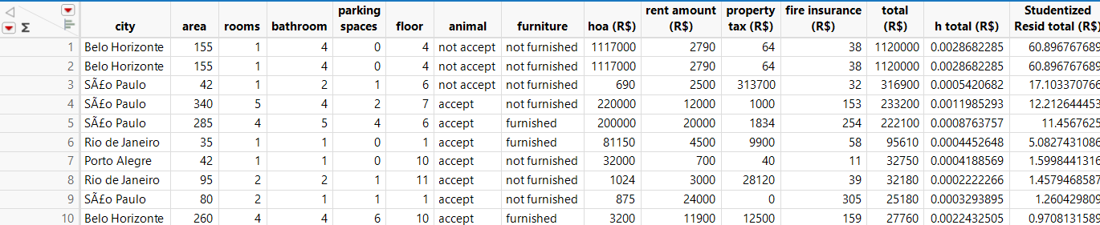
- (5 points) Focus on the five observations with the largest studentized residuals (these are like z-scores so values bigger than 4 or 5 are huge). In two sentences or less, indicate which of the six regression variables seem to be different for those four.
The five observations with the largest studentized residuals have exceptionally high total rental costs, particularly due to unusually large HOA fees and property taxes. Their values for the five regression predictors are not consistently extreme, suggesting that these observations are unusual primarily in the response variable rather than the predictors.
- (2 points) Refer to part f. Use the Exclude/Unexclude toggle to set aside those five observations and rerun the model. Copy and paste the Summary of Fit table and the Parameter Estimates table in the space below.

RSquare | 0.600318
RSquare Adj | 0.600074
Root Mean Square Error | 2867.13
Mean of Response | 5093.893
Observations (or Sum Wgts) | 8222

Term | Estimate | Std Error | t Ratio | Prob>|t|
Intercept | 307.42588 | 91.21308 | 3.37 | 0.0008*
area | 21.195157 | 0.547639 | 38.70 | <.0001*
rooms | -463.6366 | 48.03751 | -9.65 | <.0001*
bathroom | 988.70924 | 47.86946 | 20.65 | <.0001*
parking spaces | 641.35093 | 39.87715 | 16.08 | <.0001*
floor | 82.072136 | 6.24112 | 13.15 | <.0001*

- (5 points) Refer to part c. In three sentences or less, explain generally what has changed with the fit, and with the numerical value and significance of the parameter estimates.
After removing the five observations with the largest studentized residuals, R² increased substantially from 0.0463 to 0.6003, while RMSE decreased from 18,183.54 to 2,867.13, indicating a major improvement in model fit. The parameter estimates changed considerably, particularly for Rooms, Bathrooms, and Parking Spaces, with Parking Spaces changing from a negative to a positive coefficient. All five predictors became statistically significant (p < 0.0001), whereas Parking Spaces and Floor were previously nonsignificant.

In preparing this problem I read a very strange article that appeared in Academic Medicine and Surgery. The authors focused on what an acceptable value of R² would be, I guess to referees. Their conclusions were based on a survey of published studies that reported R². They concluded, R² > 0.15. Anything can get published if you find the right niche!

